PRODML Product Volume, Network Model & Time Series Usage Guide

|  |  |
| --- | --- |
| **PRODML Overview** | The PRODML standard facilitates data exchange among the many software applications used along the E&P subsurface workflow, which helps promote interoperability and data integrity among these applications and improve workflow efficiency. |
| **Version** | **Version 1.0** |
| Abstract | This guide provides a domain/business overview of how PRODML can be used to model production networks and the flows. |
| Prepared by | Energistics and the PRODML SIG |
| Date published | 30 March 2012 |
|  |  |
| Document type | User guide |
|  |  |
| Keywords: | standards, energy, data, information, process, PRODML |

For PRODML v.1.2



|  |  |
| --- | --- |
| **Document Information** | |
| **DOCUMENT VERSION** | 1.0 |
| **DATE** | 30 March 2012 |
| **Technical** | e.g., Color: R: 210 G:124, B50 |
| **Language** | US English |

Acknowledgements

This documentation was developed by the Energistics PRODML Special Interest Group (SIG) and the following member companies: Atman Consulting, Chevron, Ormerod Consulting, Performix, Saudi Aramco, and Schlumberger.

Usage, Intellectual Property Rights, and Copyright

The material described in this document was developed by and is the intellectual property of Energistics. Energistics develops material for open, public use so that the material is accessible and can be of maximum value to everyone.

Use of the material in this document is governed by the Energistics Intellectual Property Policy document and the Product Licensing Agreement, both of which can be found on the Energistics website, <http://www.energistics.org/legal-policies>.

All Energistics published materials are freely available for public comment and use. Anyone may copy and share the materials but must always acknowledge Energistics as the source. No one may restrict use or dissemination of Energistics materials in any way.

Trademarks

Energistics™, POSC®, Epicentre®, WITSML™, PRODML™, Upstream Standards. Bottom Line Results.™, The Energy Standards Resource Centre™ and their logos are trademarks or registered trademarks of Energistics. Access, receipt, and/or use of these documents and all Energistics materials are generally available to the public and are specifically governed by the Energistics Product Licensing Agreement (<http://www.energistics.org/product-license-agreement>)

|  |  |  |  |
| --- | --- | --- | --- |
| **Amendment History** | | | |
| **Version** | **Date** | **Comment** | **By** |
| 1.0 | 30 March 2012 | Initial version. | PRODML Technical Team |
|  |  |  |  |
|  |  |  |  |

Table of Contents

1 Introduction 5

1.1 Overview 5

1.2 Audience, Purpose and Scope 5

1.3 Document Conventions 5

1.4 Documentation Information 6

2 PRODML Concepts 7

2.1 Overview 7

2.2 Product Flow Model Data-Object 8

2.3 Product Volume Data-Object 9

2.4 Time Series Data-Object 10

2.5 Unique Identifiers 11

2.6 Facility Kinds 16

2.7 Time Convention and its Use 17

3 WITSML Concepts 18

3.1 Overview 18

3.2 WITSML Wells & Wellbores 18

3.3 Measured Depths 18

4 Simple Flow Network Example 19

4.1 Product Flow Model Construction 19

4.2 Associated Product Volume Report 23

5 Retrieving Static Data 24

5.1 Measured Depth Example 24

5.2 Annulus Size Example 25

6 Product Flow Model Guidance 26

6.1 Tag Alias 26

6.2 Deadband 26

6.3 Maximum Frequency 27

7 Product Volume Guidance 28

7.1 Gas-Oil and Gas-Liquid Ratios 28

7.2 Water Cut 29

7.3 Reporting at Standard Conditions (Temperature & Pressure) 30

8 Time Series Guidance 31

8.1 Asset Identifier 31

8.2 Value Status Attribute 31

9 Using Child Facility Identifiers 32

10 Multi-Lateral Well Example 34

11 Workflow Example (Saudi Aramco) 35

11.1 Overview 35

11.2 High-Level System Architecture 37

11.3 Production Unit Flow Model Construction 38

11.4 Internal Flow Model 42

11.5 Construction for a Well 42

11.6 Retrieving Historian Data 45

11.7 Retrieving Daily and Monthly Product Volume Reports 46

# Introduction

## Overview

This document is intended to provide working examples and general guidelines for using for supporting the reporting facility kinds, facility parameters, and other schema changes as required by the Energistics Change Request PCR_0012 for Saudi Aramco.

## Audience, Purpose and Scope

This guide is intended for information technology (IT) professionals who are implementing PRODML into a software application. This guide assumes that the reader has a good general understanding of PRODML and XML, and a basic understanding of the exploration and production (E&P) domain and workflows.

## Document Conventions

This documentation set uses the following typographic conventions.

| **Example** | **Description** |
| --- | --- |
| <productVolumes> | This font and color are used for code samples, examples, display text, error messages, parameter values or the value of XML elements and attributes, and XML examples. |
| **File + Open** | In syntax, words you are instructed to type appear in bold. In text, bold is used to identify the names of data types, menus, menu options, dialog boxes, and other named items in the user interface. |
| ENTER | Capital letters are used for the names of keys and key sequences, such as ENTER and CTRL+R. |
| ALT + F1 | A plus sign (+) between key names indicates a combination of keys or menu item selections. For example, ALT + F1 means to hold down the ALT key while pressing the F1 key. |
| *dTimCurrent* | Italic font is used when referring to file names, class names and methods, parameter names, variables, or the names of XML elements and attributes. |

## Documentation Information

The PRODML XML schema contains definitions and documentation of schema elements and their use. The PRODML documentation set includes the following, which can be found at <http://www.energistics.org/prodml-standard>.

| Document | Purpose/Audience |
| --- | --- |
| *Business Overview of PRODML* | Introduces the PRODML family of standards and provides an overview of what they are for and how and why they were developed. A useful introduction to PRODML for both petro-technical and IT technical professionals. |
| *PRODML Data Schema Guide* | Provides an overview of the PRODML data schemas. For IT professionals implementing PRODML. |
| *PRODML Identifier Specification* | Describes the syntax of a PRODML identifier. The concept of asset and component identifiers is pervasive within the PRODML Services Specifications. For IT professionals implementing PRODML. |
| *PRODML Generic Data Access (GDA) Web Service Specification* | Describes the core components of PRODML Generic Data Access (GDA) Web service. It specifies the contracts for the interfaces and the data schemas used in these contracts. For IT professionals implementing PRODML. |

# PRODML Concepts

## Overview

PRODML (Production Markup Language) is an industry initiative to provide open, non-proprietary, standard interfaces between software tools used to monitor, manage and optimize hydrocarbon production.[1]

This guide focuses on three PRODML data-objects:

* **Product Flow Model** – static model of flow connections used to create facility models.
* **Product Volume Report** – for reporting production flows (e.g. oil, gas, water, etc.) or other parameters (e.g. valve status, reciprocating speed, etc.).
* **Time Series** – for exchanging simple time based series of measurement data.

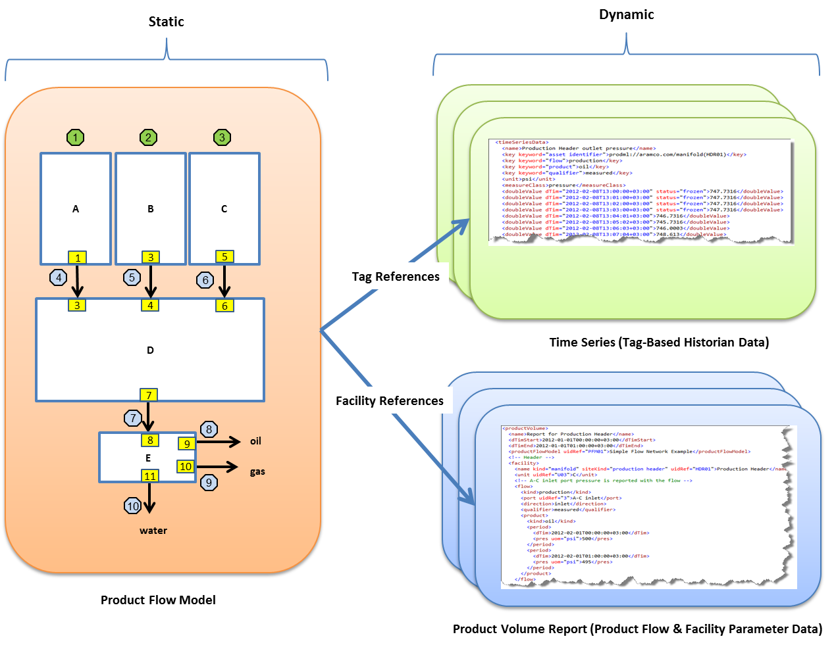

Figure Product Flow Model, Product Volume Report, and Time Series

## Product Flow Model Data-Object

The Product Flow Model data-object can be used to define a directed graph of flow connections. The basic building block is a Unit which can be used to define the flow behavior of any facility (where the term facility represents any use of equipment to perform a function) such as a separator, a wellhead, a valve, a flow line. It utilizes a general hierarchy of:

**Model** (collection of networks)

**Network** (collection of connected units)

**Unit** (black box with ports)

**Port** (allows flow in or out)

**Node** (allows ports to connect)

The Network represents the internal behavior of the model or a unit in another network and is a collection of connected units. A Unit is essentially a black box that can represent anything (big or small). Ports allow flow in or out of a Unit. Nodes are used to connect ports.

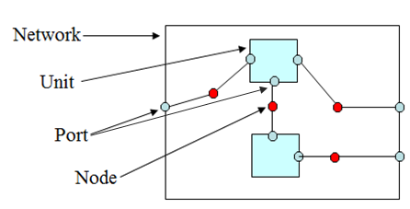

Figure Product Flow Model data-object

In any given Product Flow Model, the following is assumed:

* Steady state fluid flow across nodes and ports. That is, pressure is constant across internally and externally connected ports and nodes.
* Conservation of mass across a node or port.
* Pressure can vary internally between ports on a unit.
* Connections between models should be one-to-one so that mass balance concerns are internal to each model.

A variety of models may be created and utilized for different systems. For instance, a production accounting system will have a different model than a production operations dashboard that is used to monitor real-time data from a facility. However, by using PRODML, these various models may be exchanged used a the same standard format.

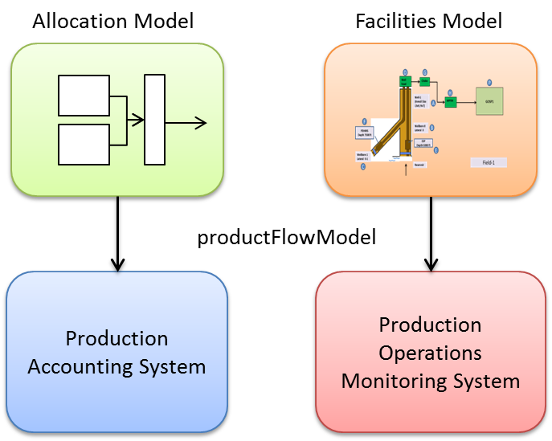

Figure 3 Various network models

## Product Volume Data-Object

The Product Volume data-object can be used to report production flows or other parameters. For instance, it can be used to report the daily allocated volume of oil production for a well or group of wells. It could also be used to report other characteristics (pressure, temperature, flow rate, concentrations, etc.) associated with a specific wellhead. It utilizes a general hierarchy of:

**Product Volume**

**Facility** (wellhead, separator, flow line, choke, completion ...)

**Parameter Set** (block valve status, reciprocating speed, available room ...)

**Parameter**

**Flow** (production, injection, export, import, gas lift ...)

**Product** (oil, water, gas, CO2, oil-gas, cuttings ...)

**Period** (instant, day, month, year …)

temperature

pressure

flow rate

Parameter Sets allow time varying "usage" parameters to be defined for the facility. For example, a valve status may be toggled from "open" to "closed" to indicate that a well is offline. The list of available values for parameters is given in the *FacilityParameter* enumeration in the *enumValuesProdml.xml* file.

Flows allow reporting for a flow of a product. For example, it may be used to specify the rate of oil produced for a specified well.

The relevant enumerations found in the *enumValuesProdml.xml* file are as follows:

* **Reporting Periods** (e.g. day, month, year, etc.) are given in the *ReportingPeriod* enumeration.
* **Facility Kinds** (e.g. wellhead, separator, flow line, choke, etc.) are given in the *FacilityParameter* enumeration.
* **Facility Parameters** (e.g. block valve status, reciprocating speed, etc.) are given in the *FacilityParameter* enumeration.
* **Flow Kinds** (e.g. production, injection, export, etc.) are given in the *ReportingFlow* enumeration.
* **Flow Qualifiers** (e.g. measured, allocated, etc. ) are given in the *FlowQualifier* and *FlowSubQualifier* enumerations.
* **Product Kinds** (e.g. oil, water, gas, etc.) are given in the *ReportingProduct* enumeration.

The combination of Flow Kind and Flow Qualifier(s) are used to characterize the underlying nature of the flow. For example, the following combination is used to indicate a production flow that is measured.

<flow>

<kind>production</kind>

<qualifier>measured</qualifier>

...

<flow>

Similarly, the following combination is used to indicate an injection flow that is simulated.

<flow>

<kind>injection</kind>

<qualifier>simulated</qualifier>

...

<flow>

## Time Series Data-Object

The Time Series data-object describes a context free, time based series of measurement data for the purpose of targeted exchanges between consumers and providers of data services. This is intended for use in support of smart fields or high-frequency historian type interactions, not reporting. It provides a “flat” view of the data and utilizes a set of keyword-value pairs to define the business identity of the series, as described in the following generalized hierarchy.

**Time Series Data**

**Meta Data**

**Keyword Name/Value Pairs** (asset identifier, qualifier, product, flow …)

**Units of Measure** (psi, rpm, mA, m …)

**Measure Class** (electric current, thermodynamic temperature, …)

**Time/Value Pairs**

The keyword value pairs are used to characterize the underlying nature of the values. The key value may provide part of the unique identity of an instance of a concept or it may characterize the underlying concept. For example, the following keyword value pairs are used to indicate the measured production flow of oil.

<key keyword="flow">production</key>

<key keyword="product">oil</key>

<key keyword="qualifier">measured</key>

The available keyword values are given by the *TimeSeriesKeyword* enumeration values from the *enumValuesProdml.xml* file as well as the following table.

| **Keyword** | **KindQualifier** |
| --- | --- |
| asset identifier | A PRODML formatted URI identifier of the asset (facility) related to the value. This captures the kind of asset as well as the unique identifier of the asset within a specified context (the authority). The identifier may define a hierarchy of assets. Refer to the *PRODML Identifier Specification* for more information on PRODML identifiers. |
| qualifier | A qualifier of the meaning of the value. This is used to distinguish between variations of an underlying meaning based on the method of creating the value (e.g., measured versus simulated). The values associated with this keyword must be from the list defined by type *FlowQualifier*. |
| subqualifier | A specialization of a qualifier. The values associated with this keyword must be from the list defined by type *FlowSubQualifier*. |
| product | The type of product that is represented by the value. This is generally used with things like volume or flow rate. It is generally meaningless for things like temperature or pressure. The values associated with this keyword must be from the list defined by type *ReportingProduct*. |
| flow | Defines the part of the flow network where the asset is located. This is most useful in situations (e.g., reporting) where detailed knowledge of the network configuration is not needed. Basically, this classifies different segments of the flow network based on its purpose within the context of the whole network. The values associated with this keyword must be from the list defined by type *ReportingFlow*. |

## Unique Identifiers

Most entities, such as *unit* in the Product Flow Model and *facility* in the Product Flow Model and Product Volume Report, have specific attributes that are used for unique identification within a system. The unit’s *uid* attribute is a unique identifier of the unit. A facility’s unique identifier is conveyed in the *uidRef* attribute, as shown in the following snippet from a Product Flow Model. Refer to the *PRODML Identifier Specification* for more information on PRODML identifiers.

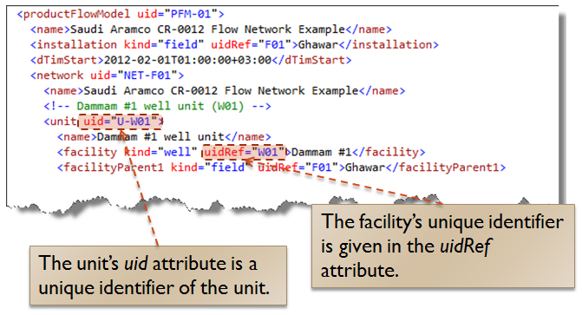

Figure 4 Unit & facility identifiers

There is an implicit relationship between the Product Flow Model and the Product Volume Report. In a Product Volume Report, several elements refer back to the Product Flow Model:

* The *productFlowModel* element is a pointer to the to the Product Flow Model for all Product Flow Units referenced within the Product Volume Report, as shown in Figure 5.
* The *unit* refers to the Product Flow Unit representing the facility, as shown in Figure 6.
* The *name* childelement of the *facility* element refers to the associated Facility. In the Product Flow Model, the *facility* child element of the *unit* element is used to identify the facility for which this Product Flow Unit describes fluid flow connection behavior. This relationship is illustrated in Figure 7.
* The *port* element refers to the Product Flow Port to which the flow is assigned. This is the port on the Product Flow Unit that represents the facility, as shown in Figure 8.

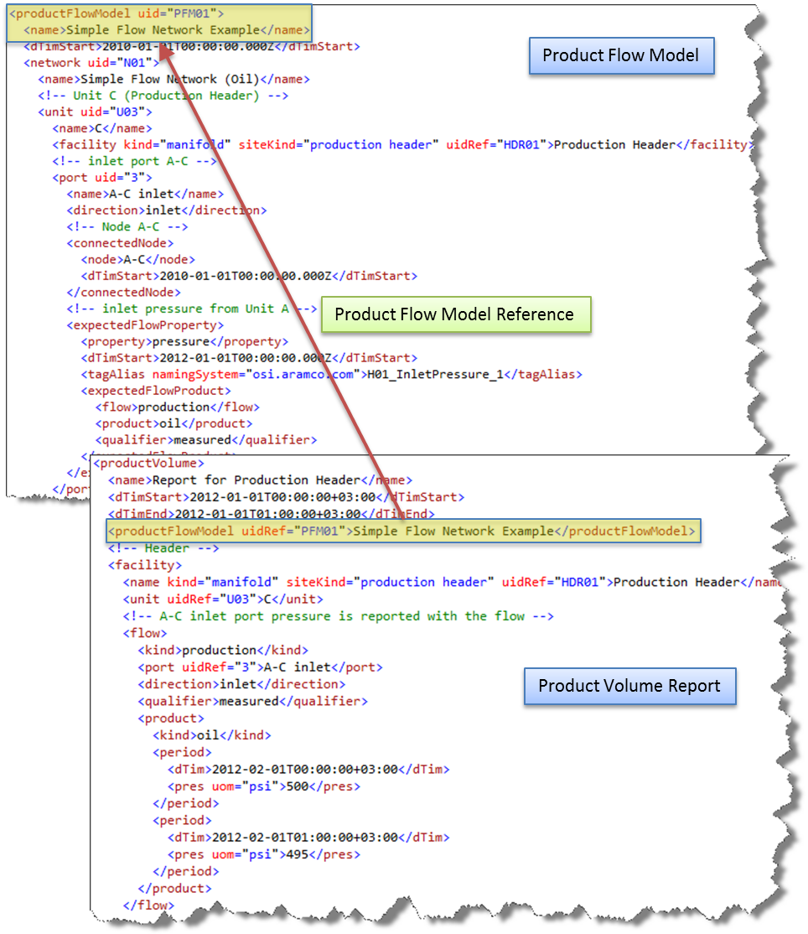

Figure Product Flow Model reference in a Product Volume Report

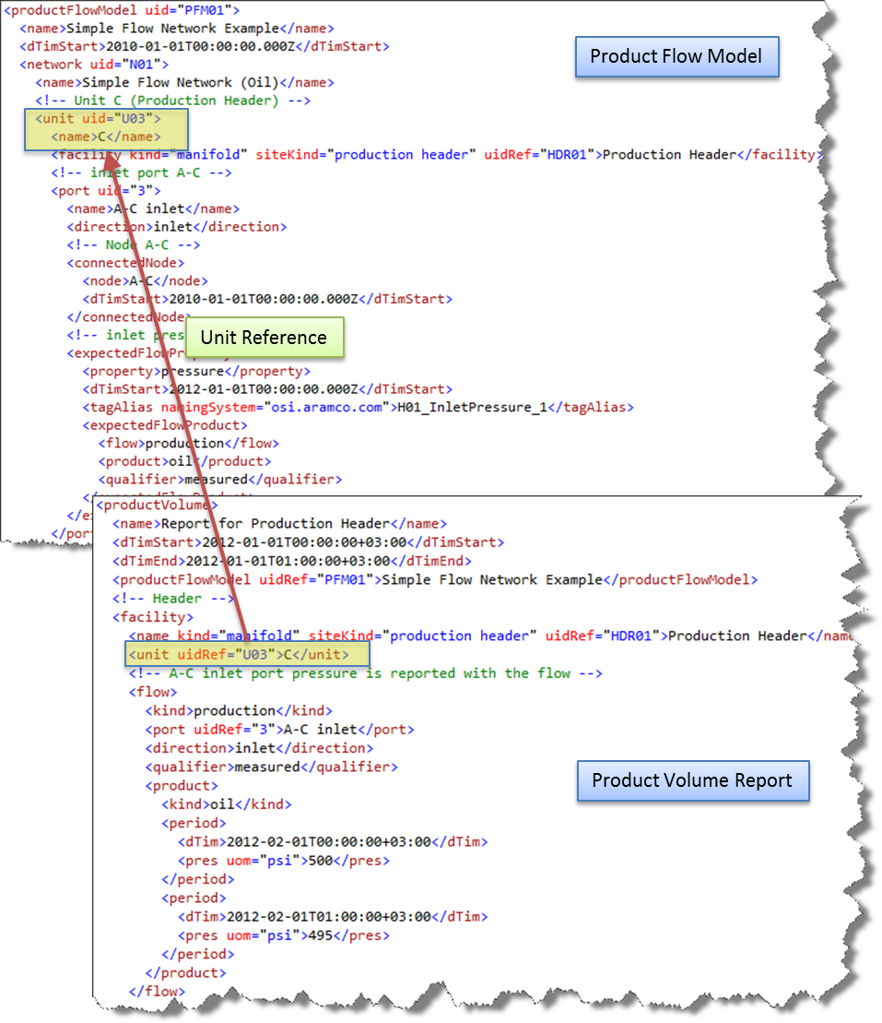

Figure Unit Reference in a Product Volume Report

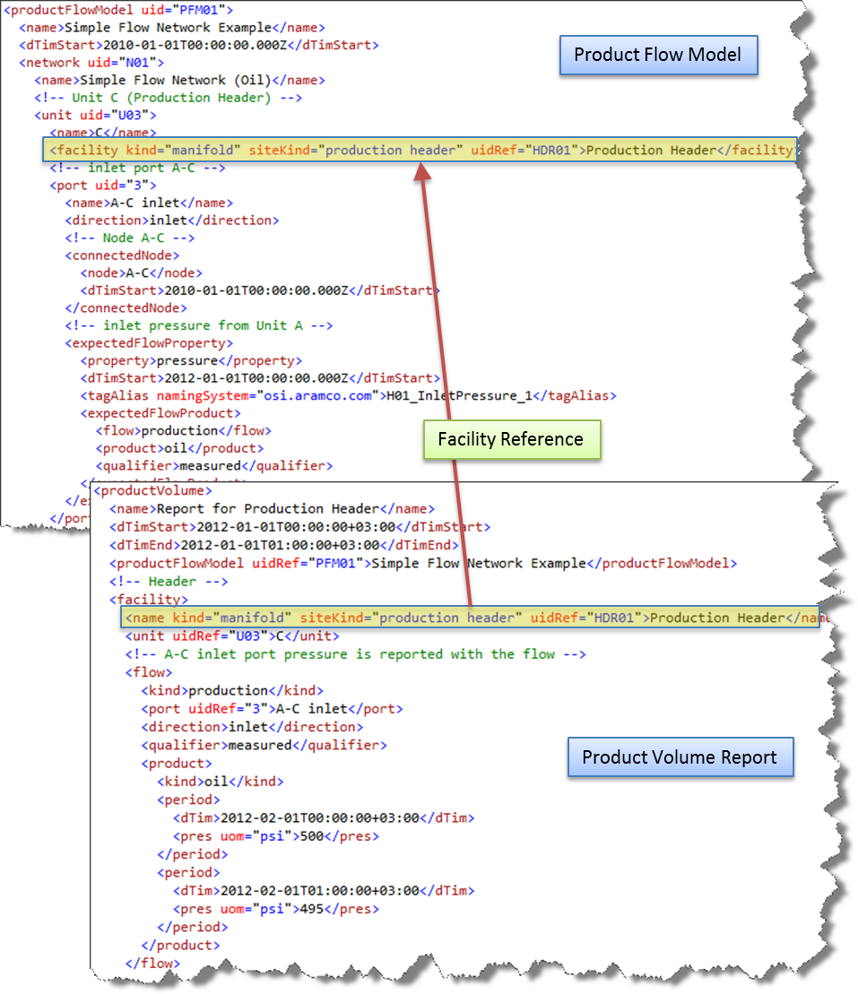

Figure Facility Reference in a Product Volume Report

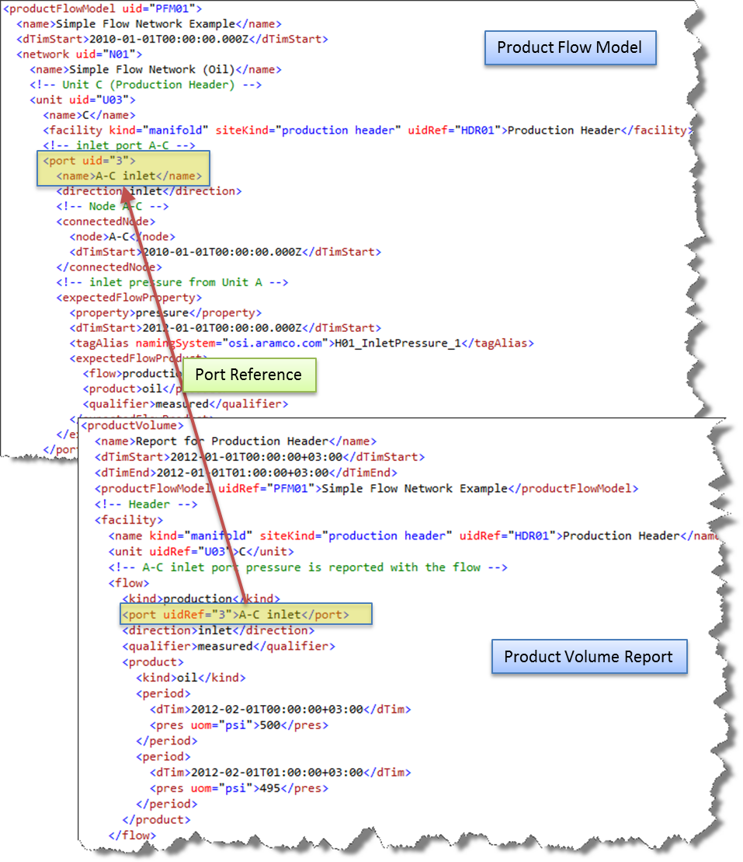

Figure Port Reference from a Product Volume Report

## Facility Kinds

In PRODML, a facility is a general term used to represent any use of equipment to perform a function (e.g. separator, wellhead, valve, flow line, etc.) Facilities are categorized by using the *kind* and *siteKind* attributes of the *facilityIdentifierStruct* in the PRODML schemas.

* The *kind* attribute must be one of the standard values available in *ReportingFacility* enumeration found in the *enumValuesProdml.xml* file.
* The *siteKind* attribute is a custom sub-categorization of facility kind intended to allow implementers to provide a more specific or specialized description of the facility kind.

NOTE: The content of the siteKind attribute is a proprietary extension and therefore not guaranteed to provide interoperability between vendors.

The following table provides describes the requested kinds from CR_0012 and the proposed solution.

| **Requested Facility** | **FacilityKind** | **Local Extension (siteKind)** |
| --- | --- | --- |
| Venturi Flow Meter | flow meter | venturi flow meter |
| Multi Phase Flow Meter | flow meter | multi-phase flow meter |
| Micromotion flow meter | flow meter | micromotion flow meter |
| Test Trap | trap | test trap |
| Orifice Meter | flow meter | orifice meter |
| Gas Lift Valve Mandrel | gas lift valve mandrel |  |
| Internal Control Valve | regulating valve | internal control value |
| Electric Submersible Pump | electric submersible pump |  |
| Permanent Downhole Monitoring System | downhole monitoring system | permanent downhole monitoring system |
| Sub-Surface Safety Valve | regulating valve | sub-surface safety valve |
| Cathodic Protection Rectifier | rectifier | cathodic protection rectifier |
| Surface Pressure Meter | pressure meter | surface pressure meter |
| Remote Terminal Unit | remote terminal unit |  |
| Test Header | manifold | test header |
| Test Line | pipeline | test line |
| Production Line | pipeline | production line |
| Production Header | manifold | production header |
| Sand Trap | trap | sand trap |
| Choke | choke |  |
| Surface Pressure Transmitter | pressure meter | surface pressure transmitter |
| Surface Temperature Transmitter | temperature meter | surface temperature transmitter |

## Time Convention and its Use

Production optimization in its various forms depends upon the ability to automate the processing of information in a continuum of time. The main reason is that optimization must adapt to the inertia of the production process and operations. The basic data for this is a combination of more frequently changing activity (from sand face to marketplace changes in flow rates, pressures and temperatures, and less frequently changing activity (scheduled outages of wells and scheduled changes in export demand, especially for gas). In turn, the applications must perform the following time-based calculations:

* Accumulation based on past time (production volumes)
* Action based on current time (especially data quality and model management)
* Forecasting of tank levels and well flow rates based on past and current time
* Integration of schedules and calculations to produce useable forecasts
* Constraint of optimization based on forecasts
* Advice based on time-based statistics and forecasted alarms

PRODML supports both requests for data values at a single timestamp and requests multiple values between two timestamps, that is, over a range of time.

If a single timestamp is specified in a query, the response should contain the data value recorded either at or before the passed timestamp. PRODML requires that the returned data value is exactly equal to the data value at or before the passed timestamp without any interpolation. If the timestamp is current time at the time of the request, the response will be considered current data: the newest available values for all measurement points.

The ability exists to query a time interval (i.e. between a start-time and an end-time). The PRODML GDA *GetData* method provides a mechanism via the *DateTimeCriterion* parameter to allow a client to specify how to treat the definition of the interval boundaries. Options for defining the boundary values are given in the following table.

| **DateTimeCriterion** | **Description** |
| --- | --- |
| Inclusive | The interval returned includes all data between and including the boundary points. |
| Exclusive | The interval returned includes all data between, but not including the boundary points. |
| Extensive | The interval returned includes all data between and including the first value outside of the boundary, if there is not a value at the boundary. |

Each end-point condition can be specified separately.

# WITSML Concepts

## Overview

WITSML™ (Wellsite Information Transfer Standard Markup Language) is an industry initiative to provide open, non-proprietary, standard interfaces for technology and software that monitor and manage wells, completions and workovers.[2]

## WITSML Wells & Wellbores

WITSML has adopted the following definitions:

* **Borehole** - A hole excavated in the Earth as a result of drilling or boring operations. The borehole may represent the hole of an entire wellbore (when no sidetracks are present), or a sidetrack extension. A borehole extends from an originating point (the surface location for the initial borehole or kickoff point for sidetracks) to a terminating (bottomhole) point.
* **Sidetrack** (or **lateral**) - A borehole that originates in another borehole as opposed to originating at the surface.
* **Wellbore** - A unique, oriented path from the bottom of a drilled borehole to the surface of the Earth. The path must not overlap or cross itself.
* **Well** - A unique surface location from which wellbores are drilled into the Earth for the purpose of either (1) finding or producing underground resources; or (2) providing services related to the production of underground resources.
* **Kickoff point** - The point where the centerline path of a wellbore representing a sidetrack splits from the centerline path of the originating (parent) wellbore. The two centerline paths coincide from this point to the surface.

The definition of wellbore is intended to allow it to *represent* one and only one sidetrack or initial borehole. This assumes that only one sidetrack can have a particular bottomhole point. The wellbore may partially or completely overlap other sidetracks but it would not represent them.

Each wellbore must be identified within the context of one well (which defines the surface location of the wellbore). Each wellbore that represents a sidetrack or lateral should specify the kickoff point in the parent wellbore.

For data bases that only contain wells, the name of the well generally contains knowledge of a specific sidetrack that is represented by that well. Information which is common to all sidetracks must be copied to each sidetrack well. Information from other sidetracks may also be redundantly copied to the sidetrack well. That is, the sidetrack well generally represents information from bottomhole to surface. In the WITSML view, the common data maps to a *well* and the sidetrack information maps to a *wellbore*. Data from other sidetracks may or may not be redundantly copied to a wellbore. Information about a borehole maps to a wellbore when that information is located using measured depths from the surface.

## Measured Depths

Measured depths represent the distance from a datum to a point along the centerline path of a wellbore. Each measured depth value must have a unit of measure and be related to one datum and one wellbore. The combination of wellbore, unit and datum *implicitly* represents one unique coordinate reference system (CRS). Any two values which represent the same CRS can be directly compared. Everything within a well is directly or indirectly located using measured depth values.

# Simple Flow Network Example

The purpose of this example is to provide a very simple example of how to construct a PRODML Product Flow Model in order to introduce the overall concepts that will be used in a more complex example in the section

Figure 9 shows a very simple production network. This network consists of two producing oil wells connected to a pipeline. Although wells typically product a combination of oil, gas, and water, we will only consider the flow of oil for the purposes of this example.

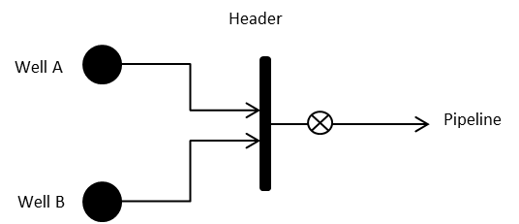

Figure 9 Simple oil production network

## Product Flow Model Construction

When constructing a Product Flow Model, it is important to differentiate between the “product” type measurements (e.g. oil rate, gas rate, pressure, etc.) which are reported at Ports, and the “facility” type measurements (e.g. motor speed, choke position, valve status, etc.) which can be measured and reported within a unit.

Information about a flow is best reported where it leaves or enters Units (facilities) which may modify the flow (e.g. separators, manifolds etc.). On the other hand facility parameters are internal to the “workings” of a facility.

**IMPORTANT: The Product Flow Model assumes:**

* **Steady state fluid flow across nodes and ports (i.e. pressure is constant across internally and externally connected ports and nodes).**
* **Conservation of mass across a node or port.**
* **Pressure can vary internally between ports on a unit.**
* **Connections between models should be one-to-one so that mass balance concerns are internal to each model.**

Construction of a PRODML flow network can be summarized in the following steps, which are further explained below:

1. Draw the real world diagram indicating measurement points.
2. Draw boundaries to include facility parameters and exclude flow measurements.
3. Make each boundary a unit in the flow network and identify the ports.

**Step 1: Draw the Diagram**

First, draw the real-world diagram indicating measurement points, as shown in the following diagram.

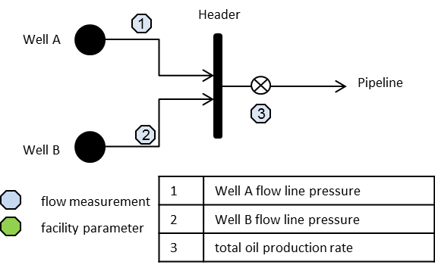

Figure 10 Measurement points for a simple flow network

**Step 2: Draw Boundaries**

The next step is to draw boundaries around items with no flow measurements, as shown in the following diagram.

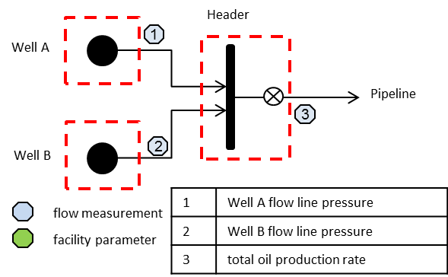

Figure 11 Unit boundaries for a simple flow network

**Step 3: Make Each Boundary a Flow Unit**

Finally, make each boundary a unit in the flow network and label each unit and node with a unique name, as shown in Figure 12.

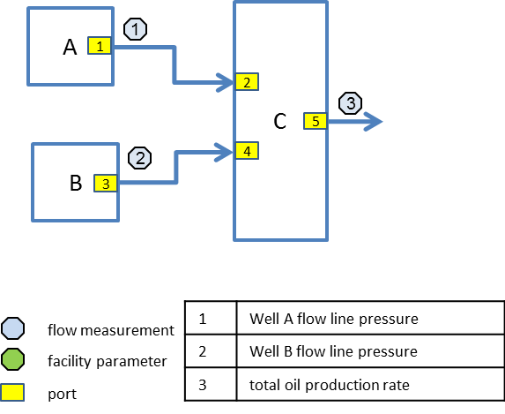

Figure 12 Simple network units and nodes

The following table summarizes the units of the flow network, assigned unique identifiers, and associated facility kinds.

Table Simple network units

| **Unit Name** | **Unit ID** | **Facility ID** | **Facility Kind** | **Kind Qualifier** | **Measurements** |
| --- | --- | --- | --- | --- | --- |
| A | U01 | W01 | well |  | (outlet) pressure |
| B | U02 | W02 | well |  | (outlet) pressure |
| C | U03 | HDR01 | manifold | production header | (outlet) oil flow rate  (outlet) pressure |

Table Simple network ports

| **Port** | **Direction** | **Connected Node** |
| --- | --- | --- |
| 1 | outlet | A-C |
| 2 | inlet | A-C |
| 3 | outlet | B-C |
| 4 | inlet | B-C |
| 5 | outlet | C-P |

Table Simple network flow properties

| **Port** | **Property** | **Flow** | **Product** | **Qualifier** |
| --- | --- | --- | --- | --- |
| 1 | pressure | production | oil | measured |
| 3 | pressure | production | oil | measured |
| 5 | pressure | production | oil | measured |
| 5 | flow rate | production | oil | measured |

Figure 13 illustrates the definition of port 5 in XML.

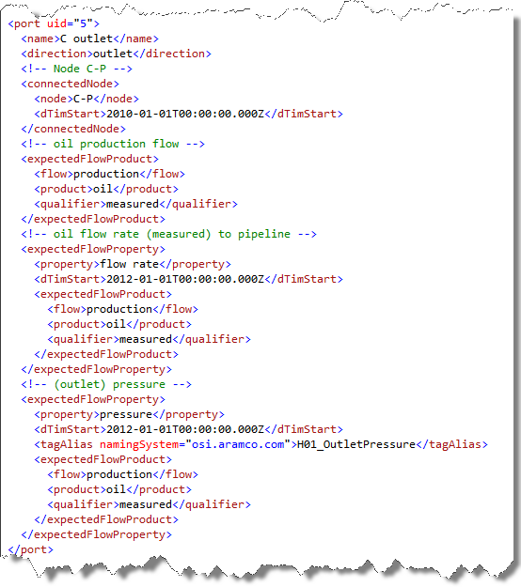

Figure Port definition example in XML

## Associated Product Volume Report

A Product Volume Report can now be associated with any given unit in the Product Flow Model. The XML snippet in Figure 14 shows how to reference the associated unit and port from a Product Volume Report.

The *unit* element provides the name and *uidRef* attribute that refers to the unique identifier for the flow unit **C** in the previous simple flow network example. Similarly, the *port* element provides the name and unique identifier for the port associated with a reported flow.

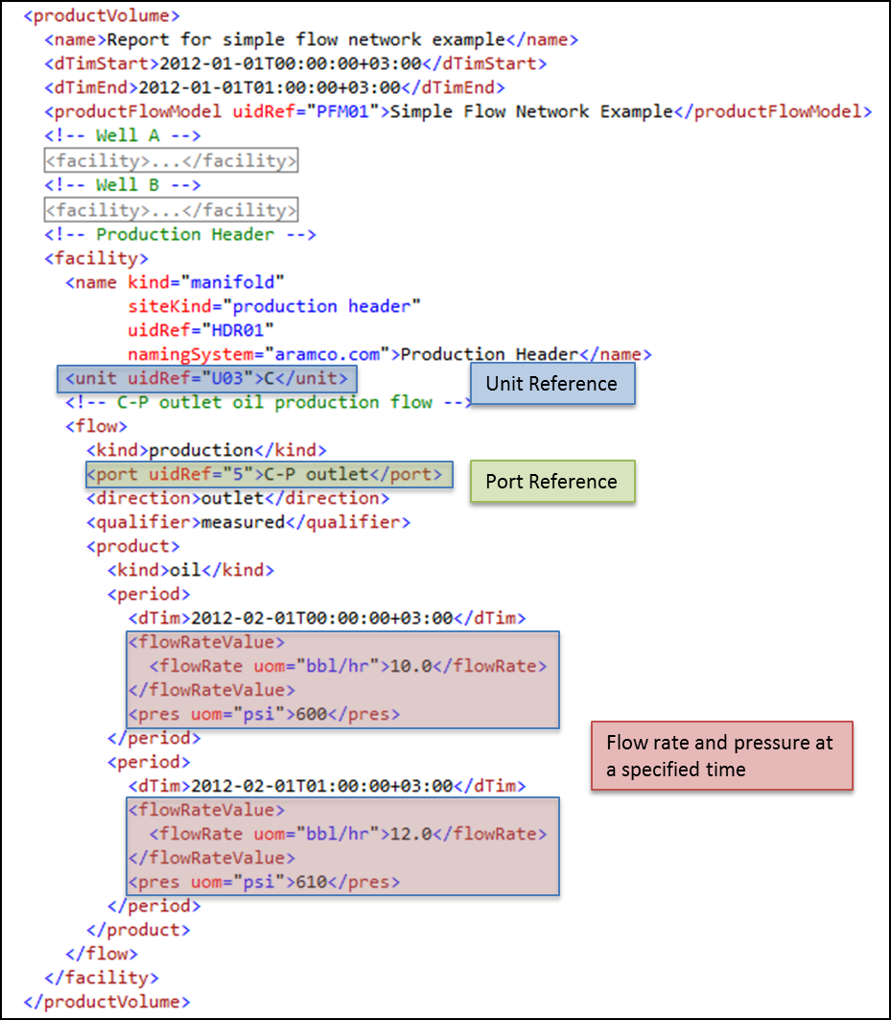

Figure Product Volume Report referencing Product Flow Model unit & port

# Retrieving Static Data

Some parameters, such as the measured depth of a piece of equipment, can be treated a static facility parameters. Static facility parameters are provided in the context of a Product Volume Report. A special category of Product Volume Report, where the kind element is specified as *static facility parameters*, is used for conveying static data.

## Measured Depth Example

The measured depth of an electric submersible pump is treated a static facility parameters. The following diagram gives an example of such a scenario.

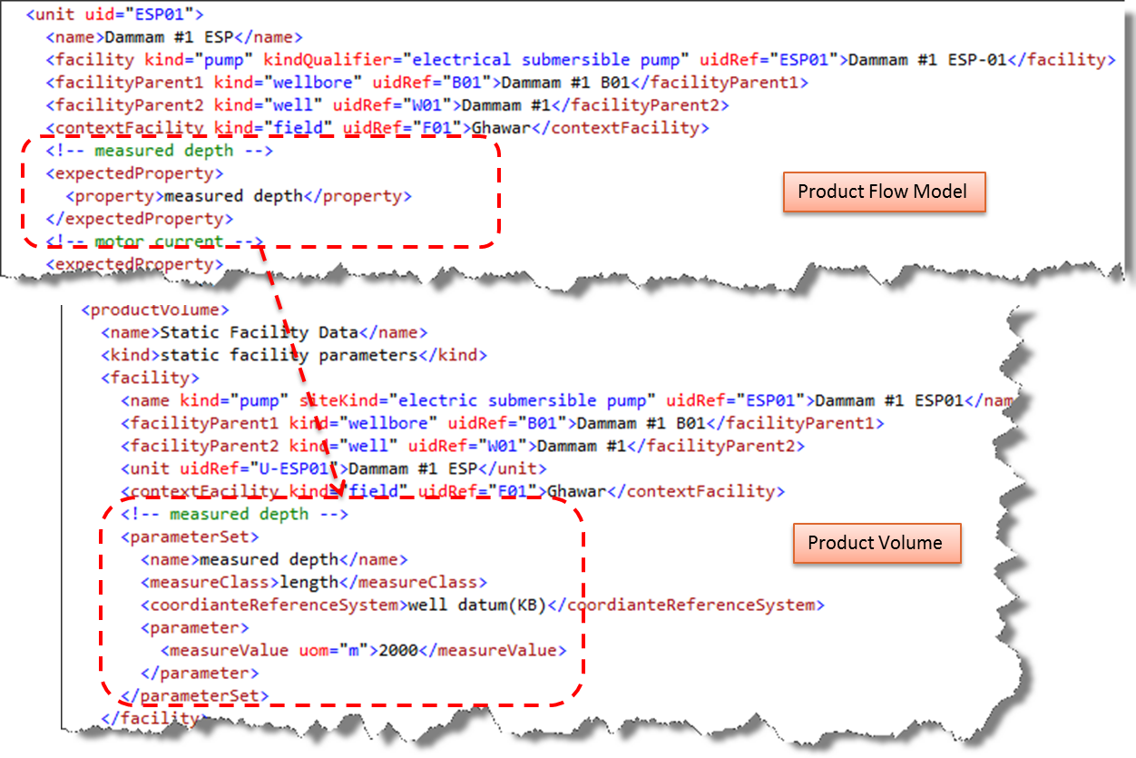

Figure Measured depth example of static facility data

If the Product Flow Model is being utilized, then *measured depth* is listed as an expected property of the facility. In this case, the facility is an *electric submersible pump*. However, the Product Flow Model is not required to be used since the measured depth of the electric submersible pump is always given in the Product Volume Report for the facility in the *parameterSet* structure as shown.

Of significant note is the *kind* element of Product Volume Report, which is specified as *static facility parameters*.

## Annulus Size Example

This example shows how to report annulus size for a wellbore in inches (e.g. 9X13 or 9x7). The annulus is the space between the innermost casing and outside of the production tubing that was installed inside the casing.

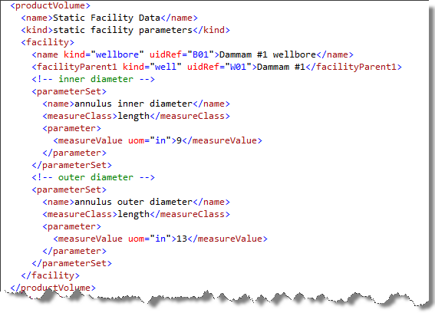

Figure Annulus size example of static facility data

# Product Flow Model Guidance

## Tag Alias

The *tagAlias* element in the Product Flow Model allows for an alternative name for the sensor that will measure a property. . As shown in Figure 17, a tag alias *ESP01_MotorCurrent* is specified for the *motor current* parameter of an electric submersible pump.

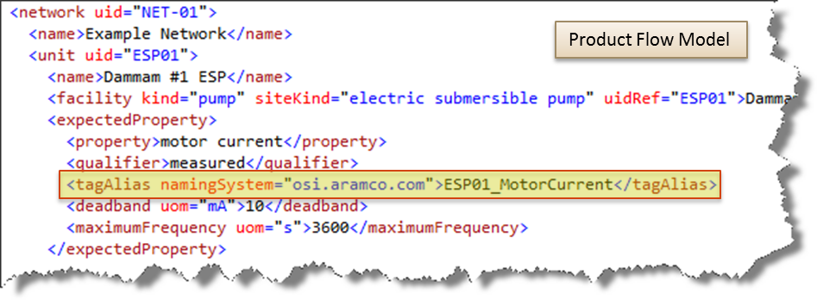

Figure Tag Alias usage in Product Flow Model

## Deadband

Deadband is the difference between two consecutive readings must exceed deadband value to be accepted. The *deadband* element in the Product Flow Model allows this information to be specified. As shown in Figure 18, a deadband value 10 milliamps is specified for the *motor current* parameter of an electric submersible pump.

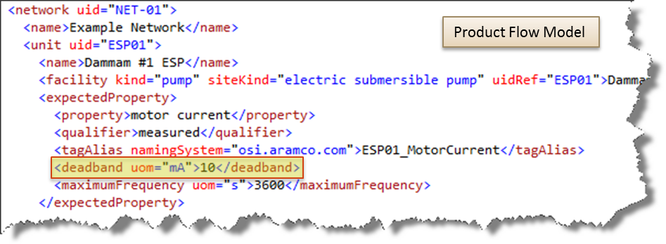

Figure Deadband usage in Product Flow Model

## Maximum Frequency

Maximum Frequency is the maximum time difference from the last sent event before the next event is sent. The *maximumFrequency* element in the Product Flow Model allows this information to be specified. As shown in Figure 18, a maximum frequency value 3600 seconds is specified for the *motor current* parameter of an electric submersible pump.

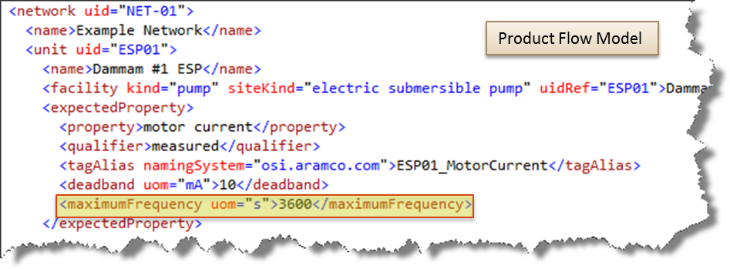

Figure Maximum Frequency usage in Product Flow Model

# Product Volume Guidance

## Gas-Oil and Gas-Liquid Ratios

Figure 20 illustrates how to include gas oil ratio (*gor* element) and gas liquid ratio (*gasLiquidRatio* element) values in a Product Volume Report. In this scenario, a multi-phase flow meter is used to report the ratios within the measured flow of the combined oil, gas, and water product stream.

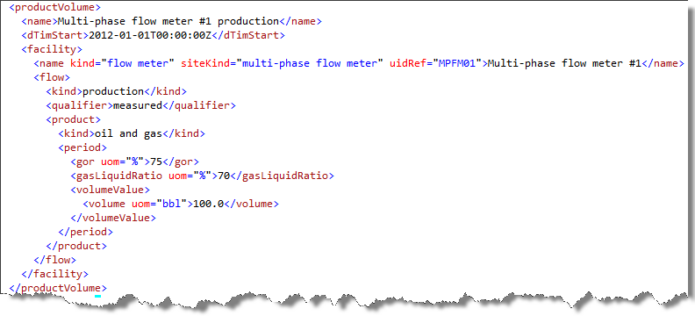

Figure Gas-oil & gas-liquid ratio example

## Water Cut

Figure 21 illustrates how to declare water cut as an expected flow property in the Product Flow Model and report the values in a Product Volume Report. In this scenario, the *ReportingProperty* value of *volume concentration* is combined with the expected flow product of *water* to indicate the water cut reported from a multi-phase flow meter.

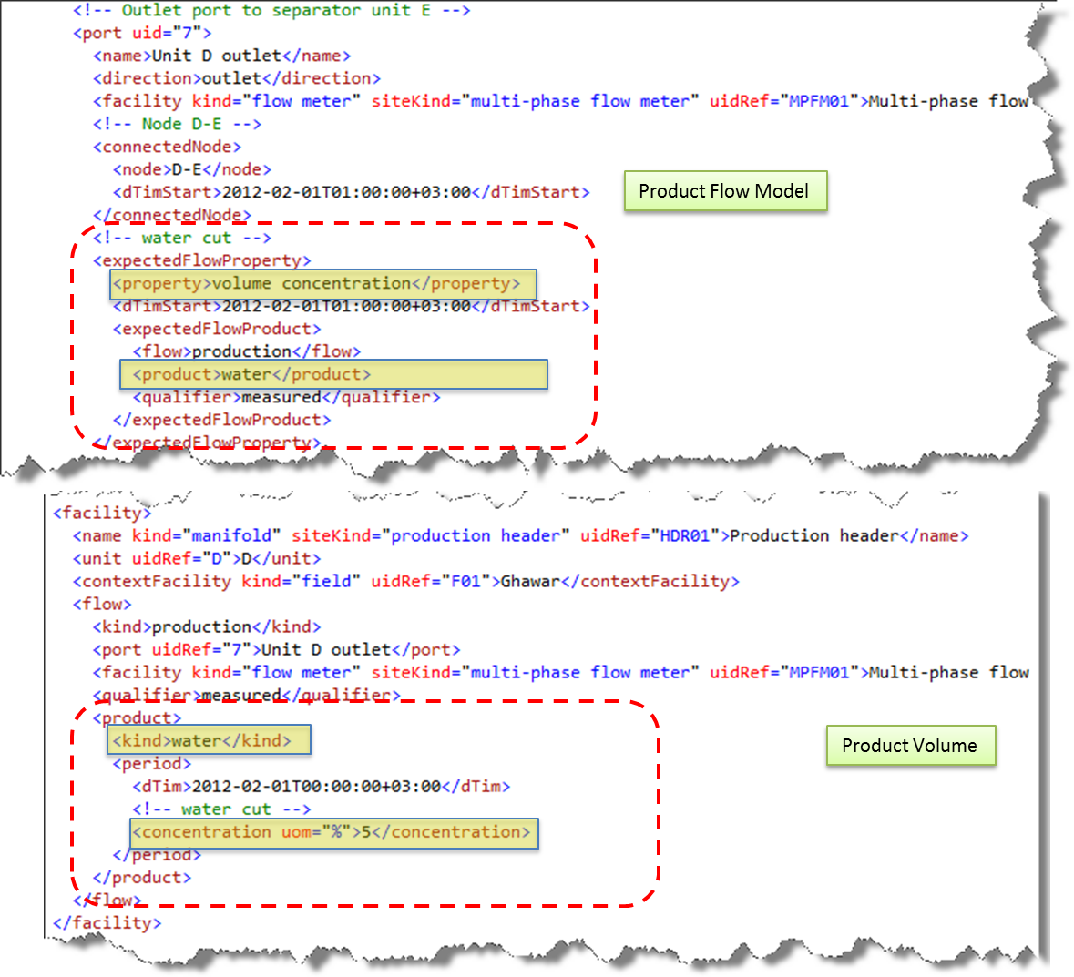

Figure Water Cut Example

## Reporting at Standard Conditions (Temperature & Pressure)

Figure 21 illustrates how to specify standard conditions in the Product Flow Model and report the standard conditions in a Product Volume Report. The *standardTempPres* element in the Product Volume Report defines the default standard temperature and pressure to which all volumes, densities and flow rates in the report have been corrected. The default may be locally overridden for an individual value. If not specified, then the conditions must be presumed to be ambient conditions (i.e., uncorrected) unless otherwise specified at a local level.

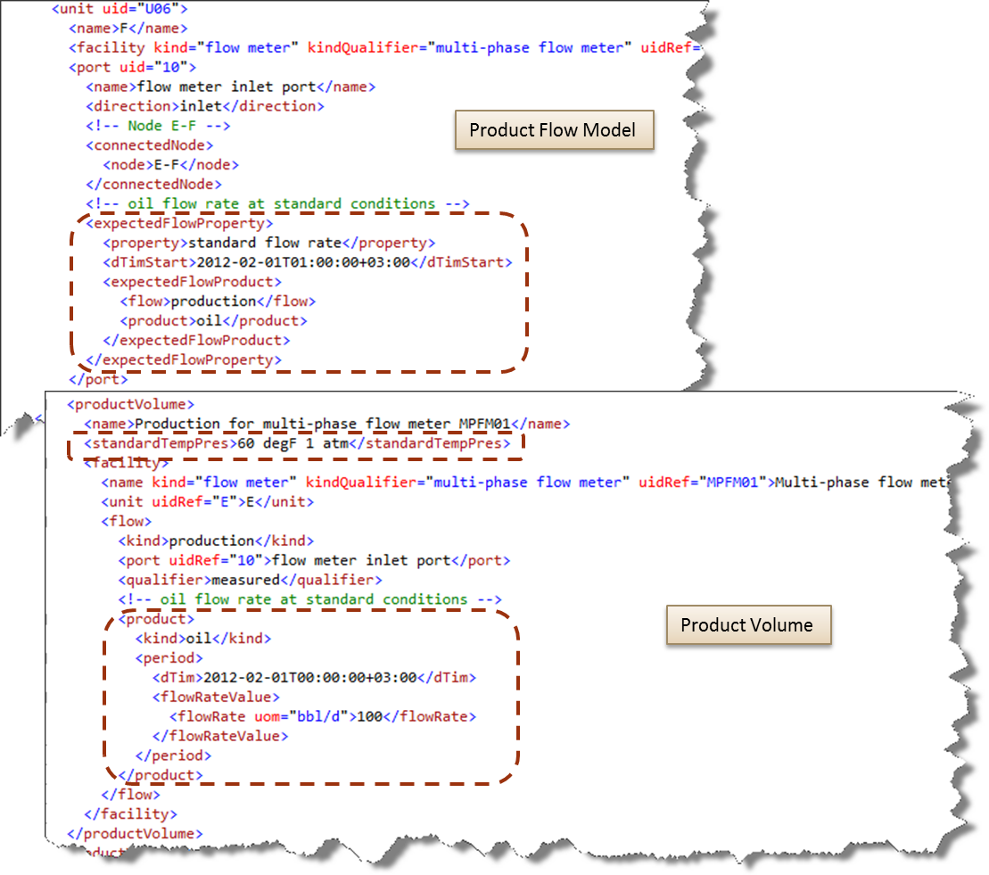

Figure Reporting at standard conditions

# Time Series Guidance

The PRODML Time Series data-object is intended for use in support of smart fields or high-frequency historian type interactions, not reporting.

## Asset Identifier

In a Time Series Data-Object, the *key* element with the keyword of *asset identifier* element refers back to the Product Flow Model. The asset identifier key is a PRODML formatted URI identifier of the asset (facility) related to the value. The identifier may define a hierarchy of assets. Refer to the *PRODML Identifier Specification* for more information on PRODML identifiers.

The example in Figure 22 shows an asset identifier for the *manifold* facility (yellow highlight) assigned the unique identifier of *HDR01* (blue highlight) in the naming system *aramco.com* (green highlight).

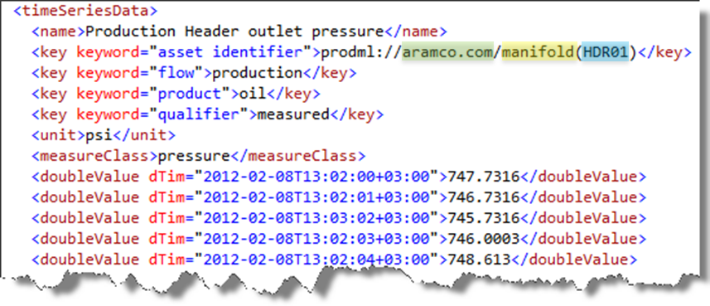

Figure Time series asset identifier example

## Value Status Attribute

In a Time Series Data-Object, the value *status* attribute is used as an indicator of the quality of the value.

**IMPORTANT: If the *status* attribute is absent and the value is not set to *NaN*, then the data value can be assumed to be good with no restrictions.**

The example in Figure 23 shows several readings with an status of frozen, which indicates the sensor has been reading the same value for a specific period of time.

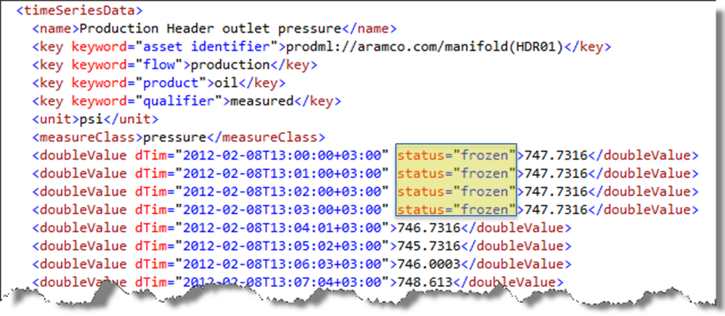

Figure Value status example

# Using Child Facility Identifiers

The Product Flow Model and the Product Volume Report both provide for the ability to convey information about embedded facilities using the *prodmlRelativeIdentifier* construct, a PRODML Relative Identifier as defined by the "PRODML Identifier" specification. It follows the general pattern of "type(id)/type(id)" where "(id)" is optional. The advantage of this approach is to simplify the resulting Product Flow Model.

EXAMPLE: Consider a wellbore that contains an electric submersible pump (ESP) as shown in Figure 24.

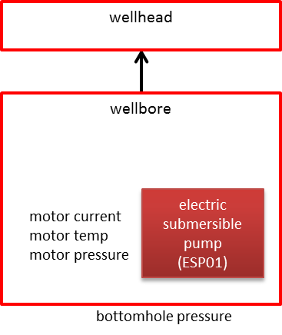

Figure Wellbore with embedded equipment

Let’s also assume that we want to measure the ESP motor current, motor temperature, and motor pressure as well as the bottomhole pressure for the wellbore. One could construct a Product Flow Model identifying each entity (wellbore, ESP, wellhead, etc.) at a very granular level. However, this approach can quickly lead to a complex flow model with many levels of embedded models.

Alternatively, we can include the internal facility information as part of the wellbore to simplify our model, as shown in Figure 25.

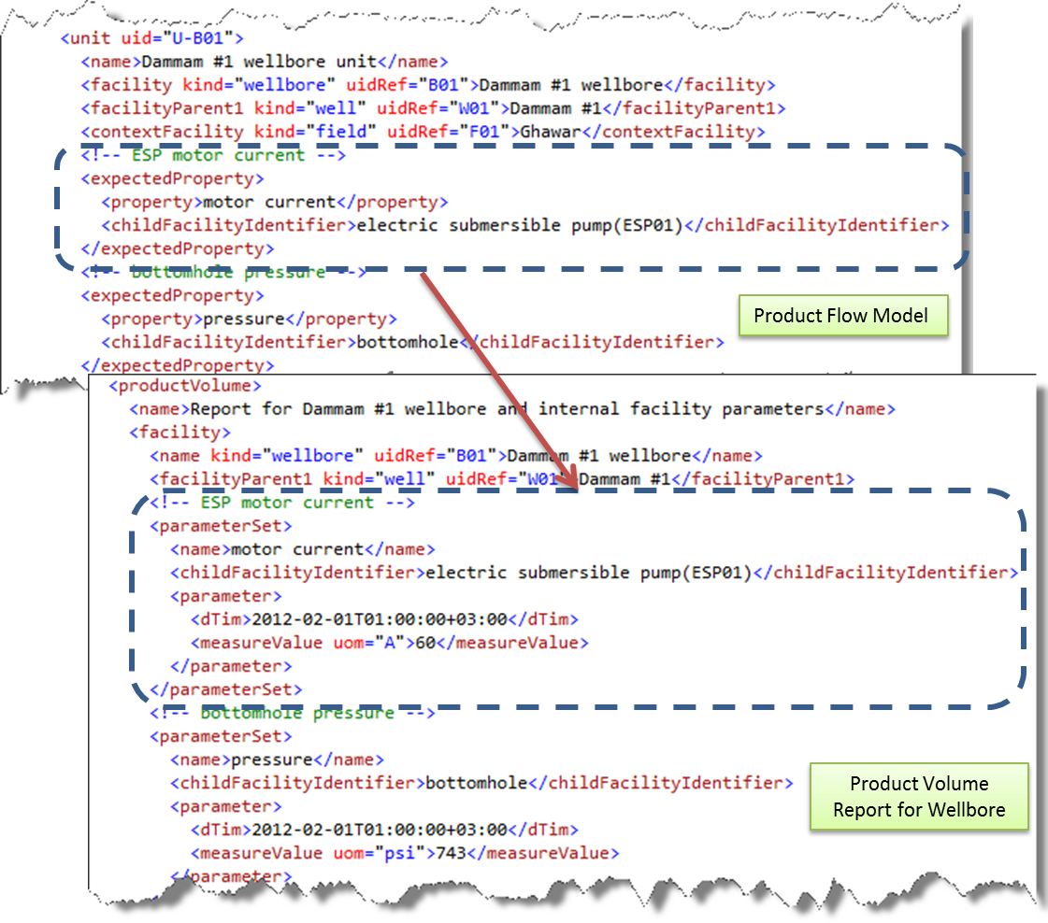

Figure Child facility identifiers in Product Flow Model and Product Volume Reports

# Multi-Lateral Well Example

A multi-lateral well is one in which there is more than one horizontal or near horizontal lateral sidetrack drilled from a single main bore and connected back to that main bore. The WITSML wellbore object is best suited for providing detailed information about a multi-lateral well, as shown in Figure 26.

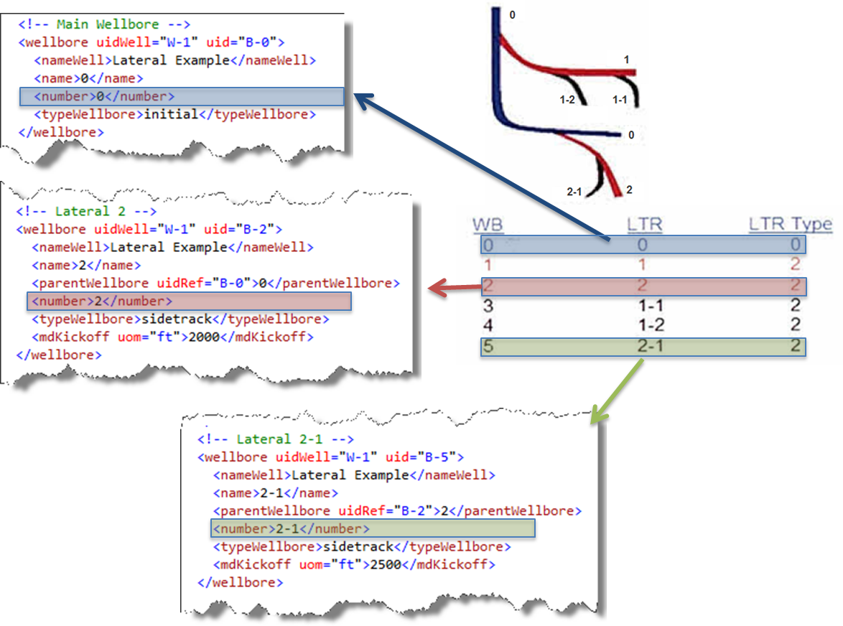

Figure Multi-lateral well example

Furthermore, a given wellbore may be references from the PRODML Product Flow Model by using the *uidRef* attribute of a unit’s *facility* element.

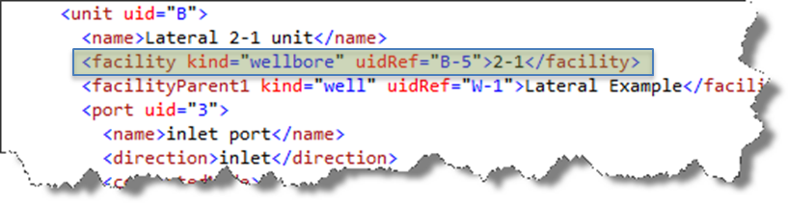

# Workflow Example (Saudi Aramco)

## Overview

Figure 27 shows the high-level model of a production unit model of the well facility that is used throughout this example. This unit has three gas wells connected to a multi-phase flow meter via a production header. The product flows are then connected to a separator, which separates the mixed products into oil, gas, and water flows.

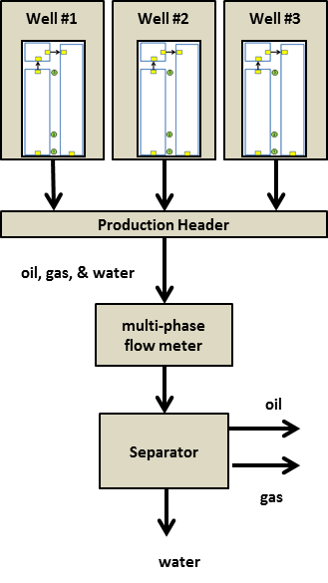

Figure 28 Example production unit

Figure 28 shows the detailed model of one of the well facilities in the previous diagram. The well in this example has two wellbores – the original hole and a lateral. In many cases, the flow from a well is connected to a valve which directs the flow to either the test line or the production line. However, for this example, we only consider the case where the wells are connected directly to the production header.

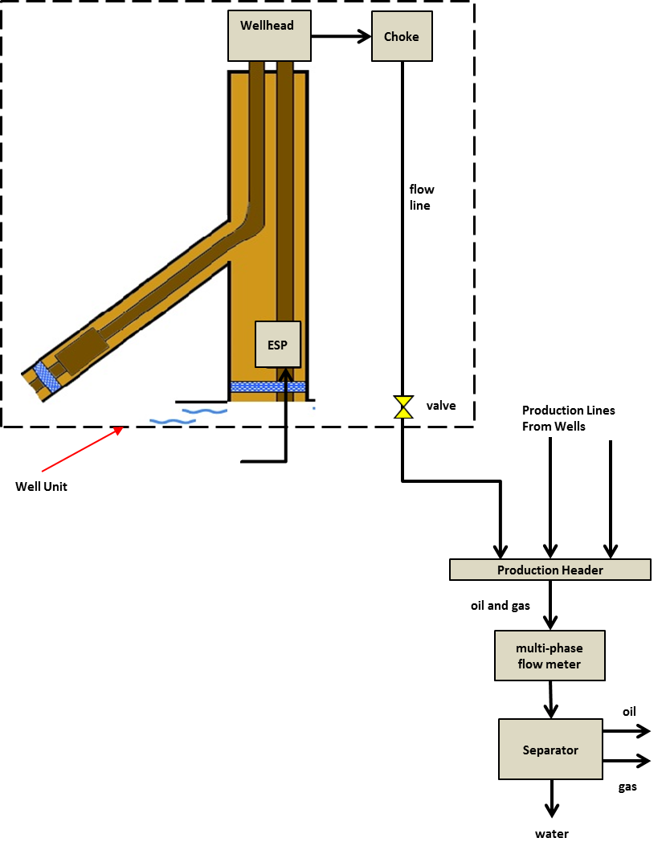

Figure 29 Facility model showing well detail

## High-Level System Architecture

The following diagram shows a possible system architecture where PRODML is used to integrate various systems.

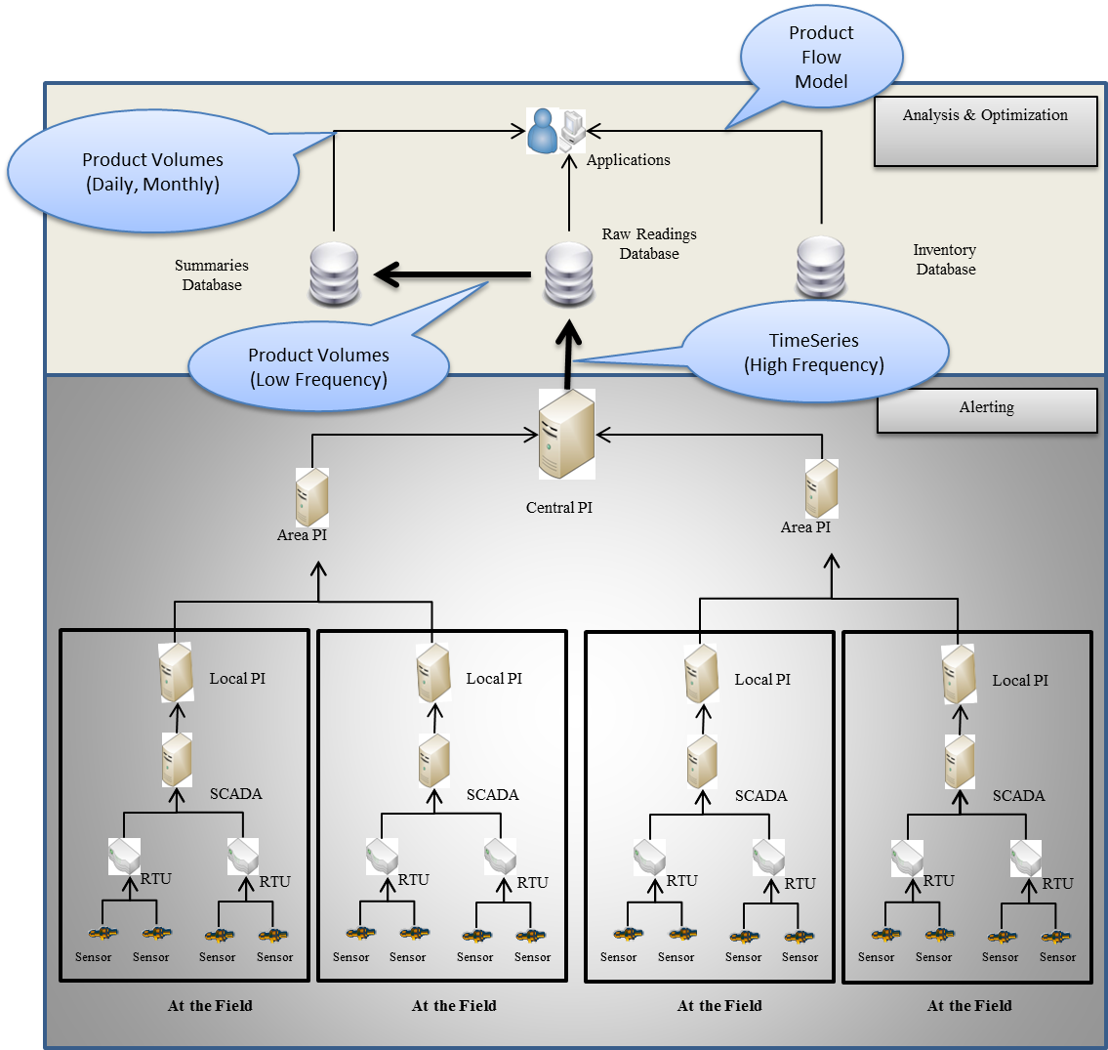

Figure 30 High-level system architecture example using PRODML

## Production Unit Flow Model Construction

The first step is to draw the real world diagram indicating measurement points, as shown in Figure 30.

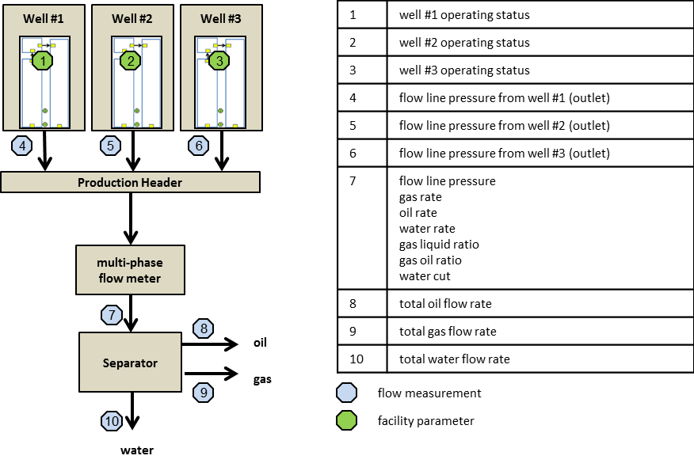

Figure 31 Production unit measurement points

The next step is to draw boundaries around items with no flow measurements, as shown in Figure 31.

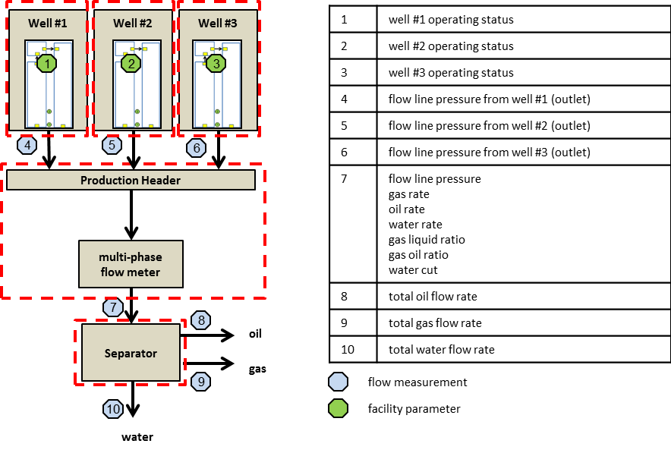

Figure 32 Production unit boundaries

Finally, make each boundary a unit in the flow network, label each unit and port with a unique name or number, as shown in Figure 32

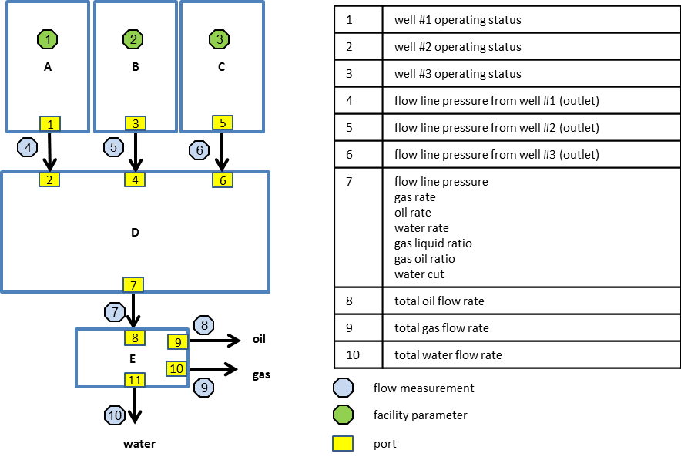

Figure 33 Production unit flow network

Table Product Flow Model Units

| **Unit** | **Facility Name** | **Facility ID** | **Facility Kind** | **Site Kind** | **Internal Network** |
| --- | --- | --- | --- | --- | --- |
| A | Dammam #1 | W01 | well |  | NET-W01 |
| B | Dammam #2 | W02 | well |  | NET-W02 |
| C | Dammam #3 | W03 | well |  | NET-W03 |
| D | Production header | HDR01 | manifold | production header |  |
| E | Separator #1 | SEP01 | separator |  |  |

Table Product Flow Model Expected Flow Properties

| **Port** | **Property** | **Flow** | **Product** | **Qualifier** |
| --- | --- | --- | --- | --- |
| 1 | pressure | production | oil and gas | measured |
| 3 | pressure | production | oil and gas | measured |
| 5 | pressure | production | oil and gas | measured |
| 7 | pressure | production | oil and gas | measured |
| 7 | temperature | production | oil and gas | measured |
| 7 | gas liquid ratio | production | oil and gas | measured |
| 7 | gas oil ratio | production | oil and gas | measured |
| 7 | flow rate | production | oil and gas | measured |
| 7 | flow rate | production | gas | measured |
| 7 | flow rate | production | oil | measured |
| 7 | flow rate | production | water | measured |
| 7 | volume concentration | production | water | measured |
| 9 | flow rate | production | oil | measured |
| 10 | flow rate | production | gas | measured |
| 11 | flow rate | production | water | measured |

**IMPORTANT: The product value of *oil and gas* refers to a combination of oil, water, and gas and is used to indicate all products in a flow.**

## Internal Flow Model

## Construction for a Well

The first step is to draw the real world diagram indicating measurement points, as shown in Figure 33.

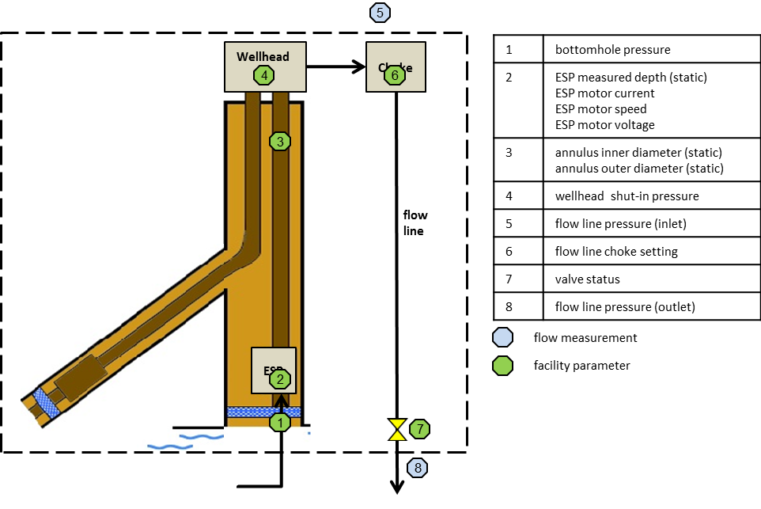

Figure Internal flow model measurement points

The next step is to draw boundaries around items with no flow measurements, as shown in Figure 34.

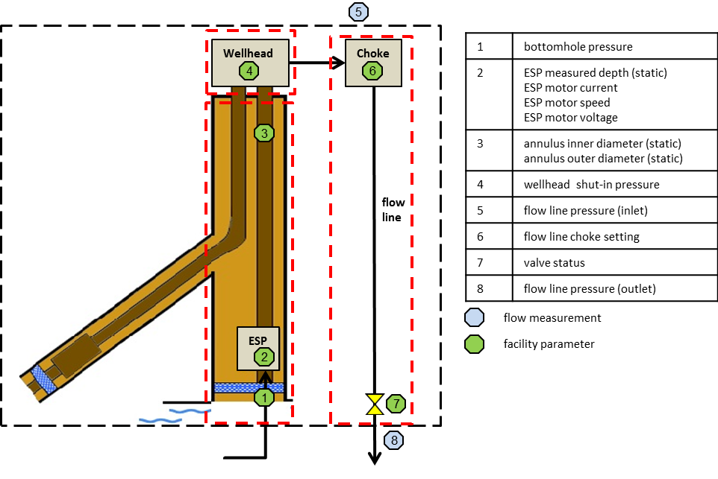

Figure 35 Internal flow model boundaries

Finally, make each boundary a unit in the flow network, label each unit, node, and port with a unique name, as shown in Figure 35.

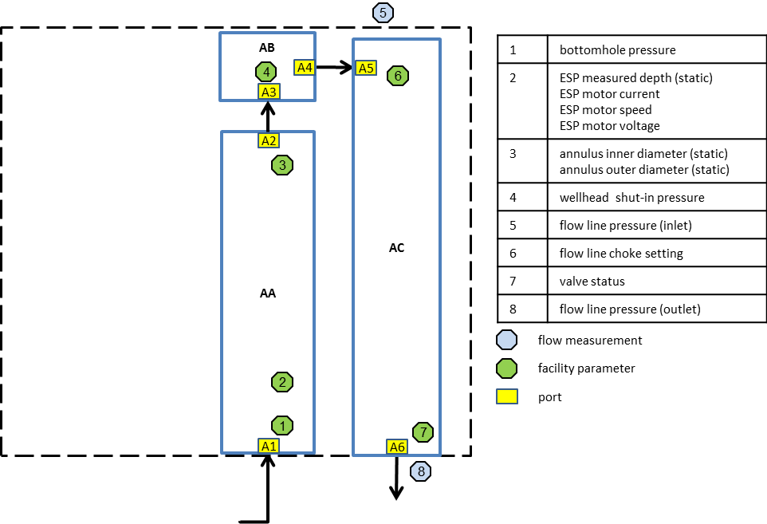

Figure 36 Internal flow model

## Retrieving Historian Data

The PRODML *timeSeriesData* data-object is a best fit for retrieving tag-based, high-frequency data from the raw readings database.

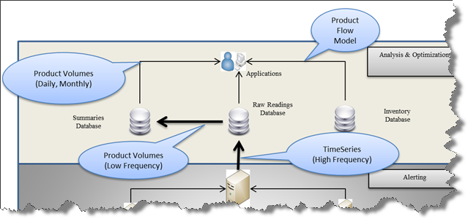

Each measurement property in the flow model contains a *tagAlias* element which is used to retrieve a *timeSeriesData* data-object. Refer to the *PRODML Identifier Specification* for more information on PRODML identifiers.

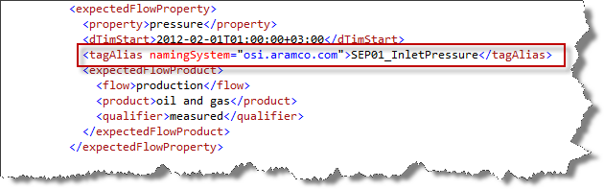

Figure 37 Tag alias in flow model

The corresponding *timeSeriesData* would be similar to the example in Figure 37.

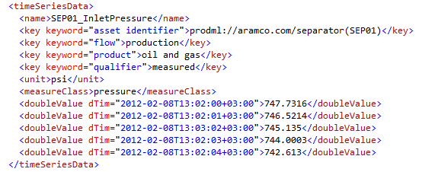

Figure Historian time series example XML

## Retrieving Daily and Monthly Product Volume Reports

The PRODML *productVolume* data-object is a best fit for retrieving historical production data from the summaries database.



The PRODML *productVolume* would be similar to that in Figure 38.

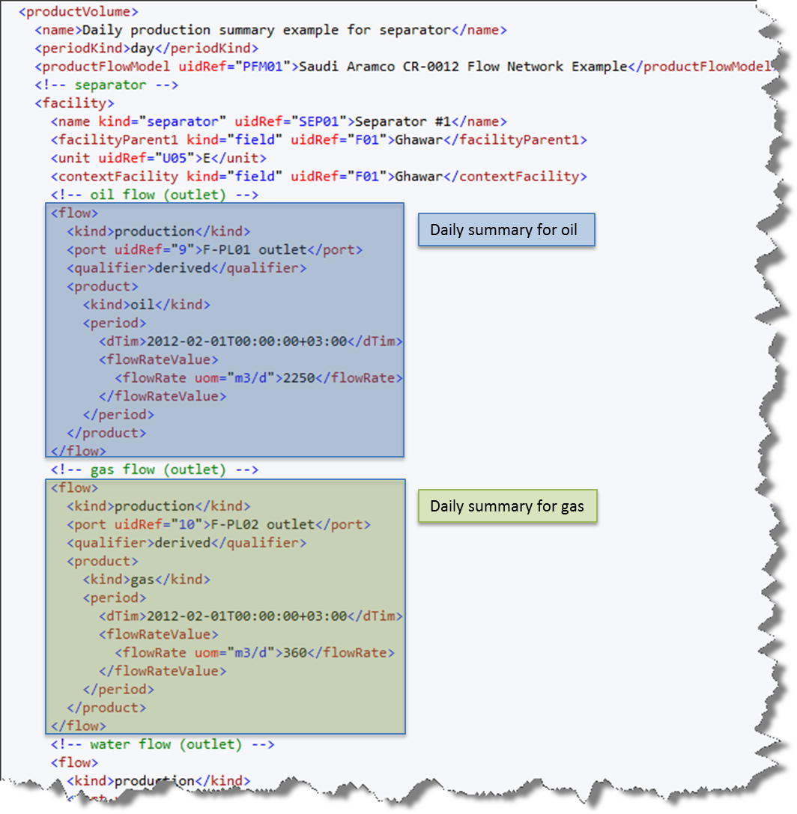

Figure Daily production example from summary database

1. <http://www.energistics.org/prodml-standard>
2. <http://www.energistics.org/witsml-standard>